Food Access Across Various Demographics and Counties in Maine

Joshua Koshy  
August 17, 2024

Abstract

For this study, I was able to collect data from the U.S Department of Agriculture entitled “Food Environment Atlas”, which identified several factors affecting access to healthy food (grocery stores) in American counties. From this data, I analyzed the populations for 4 distinct groups and observed changes from 2010 to 2015 in Maine. These groups included individuals with low access to a store, individuals with low access to a store and low income, children with low access to a store, and seniors (65+) with low access to a store. Additionally, I analyzed low access across distinct ethnic groups within Maine. The results of this analysis allowed me to identify counties in which low access had increased and demographics with disproportionately low access.

Keywords: Low Access to Store, Low-Income, Food Insecurity

Food Access Across Various Demographics and Counties in Maine

When we consider issues such as food access, what often comes to mind are 3rd world and underdeveloped countries. However, low access to healthy food is very much an issue here in the United States. According to Feeding America, “44 million people in the United States are food insecure” including over “13 million children” (Feeding America). For this reason, I decided to research this issue for my study. I used the dataset “Food Environment Atlas” from the U.S Department of Agriculture for my analysis (USDA). The data I found was very exhaustive and included data on all U.S counties. To simplify my analysis, I chose to use data for the state of Maine as it was convenient for visualization and provided enough detail to identify trends and make conclusions from the data. The rest of this paper will be devoted to presenting the conclusions of my analysis on populations with low access to food in Maine. For reference, the (low access) population in each figure will measure the “number of people in a county living more than 1 mile from a supermarket or large grocery store if in an urban area, or more than 10 miles from a supermarket or large grocery store if in a rural area. (USDA)” The first 4 figures will present data from 2010 and 2015 while the final figure only contains data for 2015.

# Low Access to Store Population per County in Maine

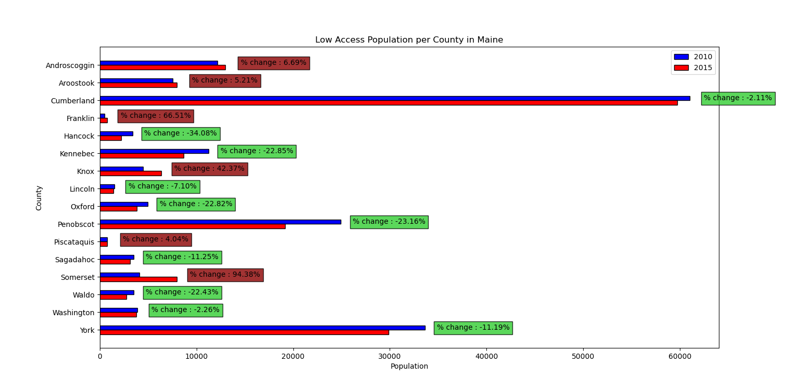

The above graph displays the “Low Access to Store” populations per county in 2010 and 2015 in the state of Maine. Labeled beside the bars for each county is the percent change between the 2015 population and the 2010 population. A negative percent change indicates that the low access population has decreased from 2010 to 2015 and is shaded green to signify this improvement in food access. A positive percent change indicates that the low access population has increased from 2010 to 2015 and is shaded red to signify this deterioration. Based on this, one can see that 6 counties: Androscoggin, Aroostook, Franklin, Knox, Piscataquis, and Somerset, had reduced access to stores in 2015. This indicates that while food access has increased in many counties, the issue is not sufficiently addressed in others where progress has reversed.

# Low Access to Store and Low-Income Population per County in Maine

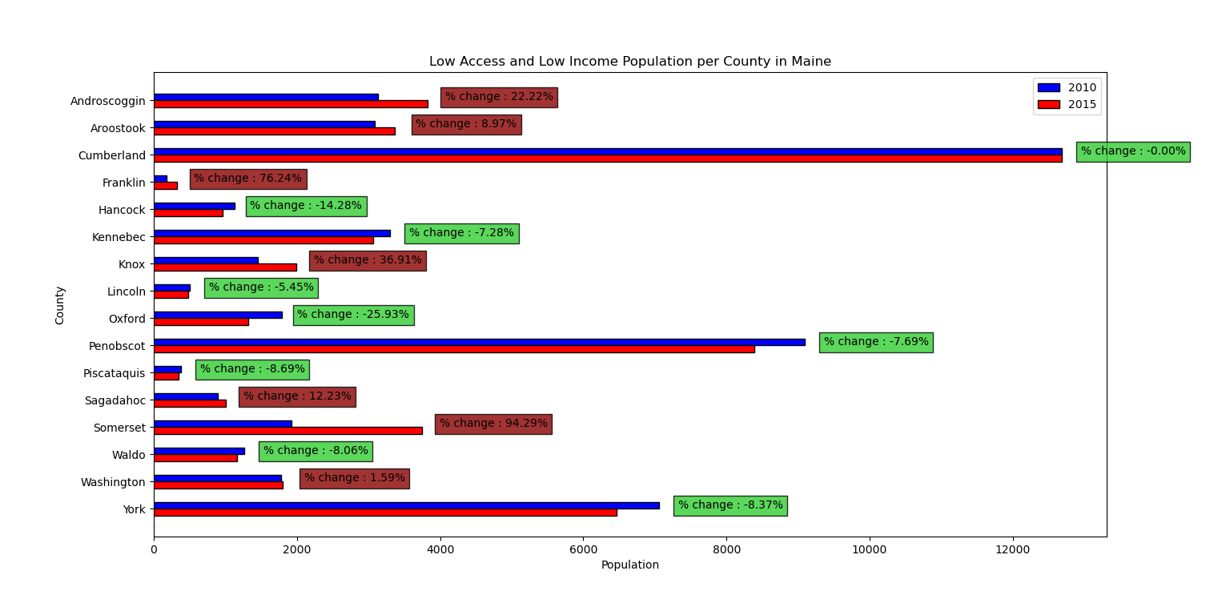

The above graph displays the populations with “Low Access to Store” and “Low-Income” per county in 2010 and 2015 in the state of Maine. Labeled beside the bars for each county is the percent change between the 2015 population and the 2010 population. A negative percent change indicates that the low access/low-income population has decreased from 2010 to 2015 and is shaded green to signify this improvement in food access. A positive percent change indicates that the low access/low-income population has increased from 2010 to 2015 and is shaded red to signify this deterioration. Based on this, one can see that 7 counties: Androscoggin, Aroostook, Franklin, Knox, Sagadahoc, Somerset, and Washington, had reduced access to stores in 2015. Comparing this data to the previous graph reveals some special insights. Firstly, the population values for “low access and low-income" were significantly lower than the “low access” only graph. This tells us that while many individuals with low access to stores come from low-income households, they are not the only ones struggling with this issue. In fact, in Maine, it appears that many counties have a greater proportion of non-low-income individuals with low access to stores. From the data, we can see that the issue of food access transcends economic boundaries and affects more than just “poor” individuals. It can also be observed that the counties where access was reduced in 2015 are different in both graphs, revealing that different counties need to address this issue differently based on their specific needs. Overall, this graph reveals that low food access heavily affects low-income individuals (relative to their percentage of the population), though not to ignore its effect on other groups as well. Once again, while the issue has improved in some counties, it remains prevalent in the state.

# Low Access to Store Child Population per County in Maine

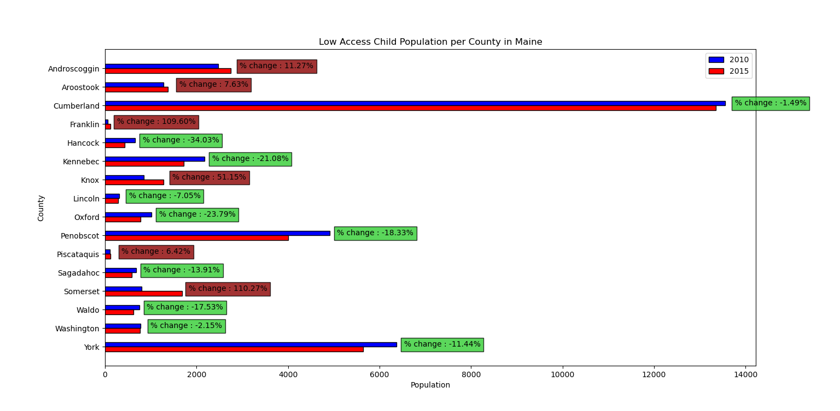 The above graph displays the “Low Access to Store” child populations per county in 2010 and 2015 in the state of Maine. Labeled beside the bars for each county is the percent change between the 2015 population and the 2010 population. A negative percent change indicates that the low access child population has decreased from 2010 to 2015 and is shaded green to signify this improvement in food access. A positive percent change indicates that the low access child population has increased from 2010 to 2015 and is shaded red to signify this deterioration. Based on this, one can see that 6 counties: Androscoggin, Aroostook, Franklin, Knox, Piscataquis, and Somerset, had reduced access to stores in 2015. This data strongly correlates with the “low access” population data from the first graph. The graph reveals that food access has especially worsened in the counties of Franklin and Somerset, where the low access child population has more than doubled.

# Low Access Senior Population per County in Maine

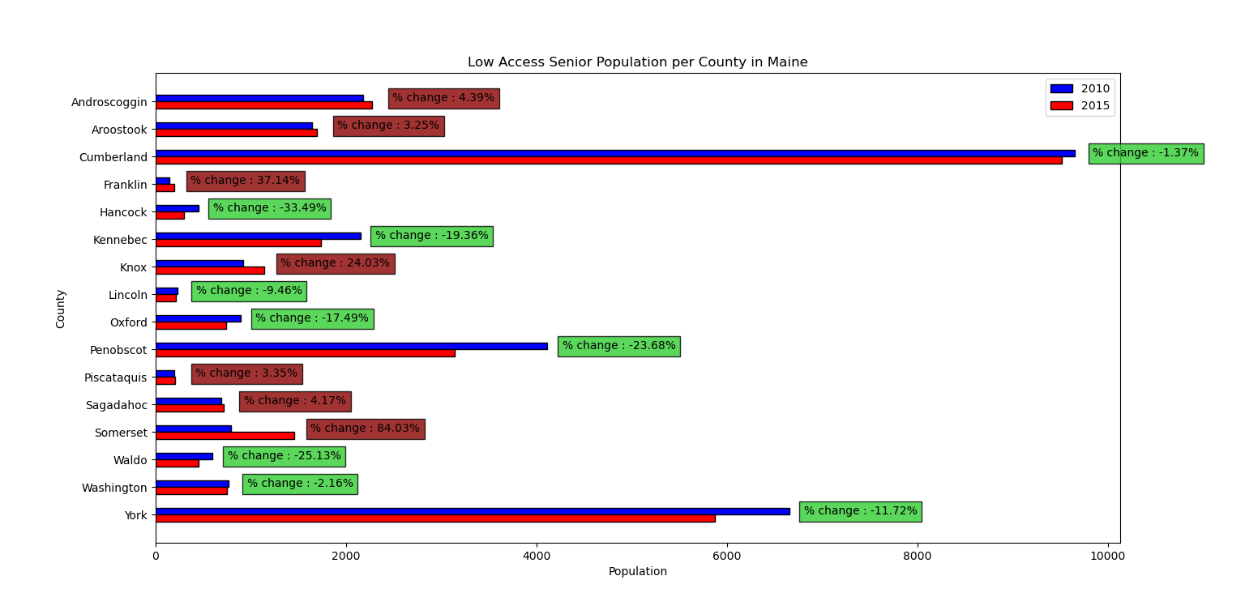

The above graph displays the “Low Access to Store” senior (65+) populations per county in 2010 and 2015 in the state of Maine. Labeled beside the bars for each county is the percent change between the 2015 population and the 2010 population. A negative percent change indicates that the low access senior population has decreased from 2010 to 2015 and is shaded green to signify this improvement in food access. A positive percent change indicates that the low access senior population has increased from 2010 to 2015 and is shaded red to signify this deterioration. Based on this, one can see that 7 counties: Androscoggin, Aroostook, Franklin, Knox, Piscataquis, Sagadahoc, and Somerset, had reduced access to stores in 2015. As one of the most vulnerable populations, it should be alarming that food access has decreased in this many counties. Action should be taken as soon as possible to protect this at-risk group.

# Low Access Population by Demographic in Maine

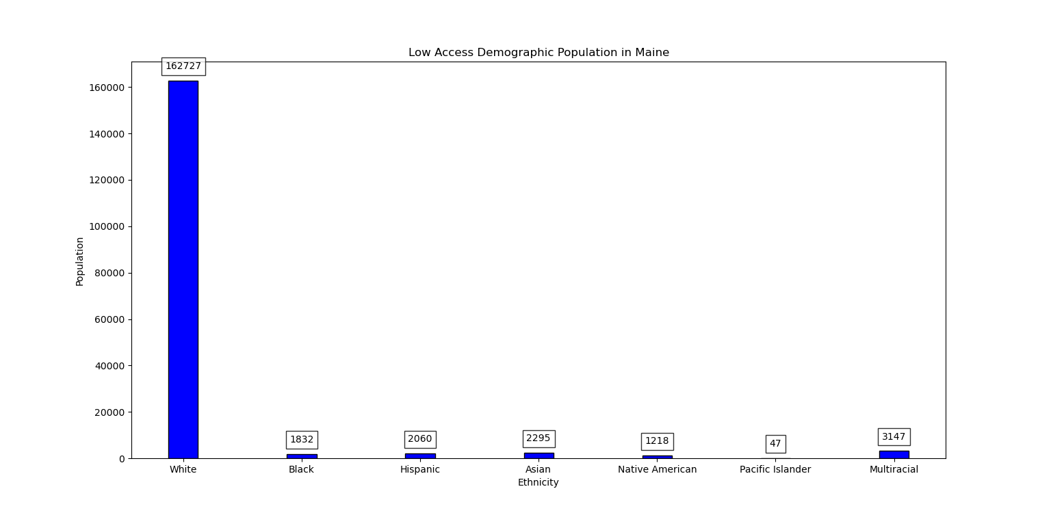 The above graph displays the “Low Access to Store” populations per ethnic group in 2015 in the state of Maine. The figure appears to show an extremely high white population; however, it is important to note that white people make up over 90% of the total population in Maine. Therefore, we can consider this value an outlier and look at the other ethnic groups for more careful study. Because each value depends on the proportion of the total population that each demographic holds, it is difficult to draw any strong conclusions from this data.

# Conclusion

In conclusion, this study revealed that low access to stores and healthy food affect all groups and counties in Maine. From this data, I was able to find counties in which food access has decreased over time, which require greater attention and action. By studying this data, state and local governments can improve food access across the nation.

References

Economic Research Service (ERS), U.S. Department of Agriculture (USDA). Food Environment Atlas. https://www.ers.usda.gov/data-products/food-environment-atlas/

America, F. (n.d.). Hunger in America. Feeding America. https://www.feedingamerica.org/hunger-in-america